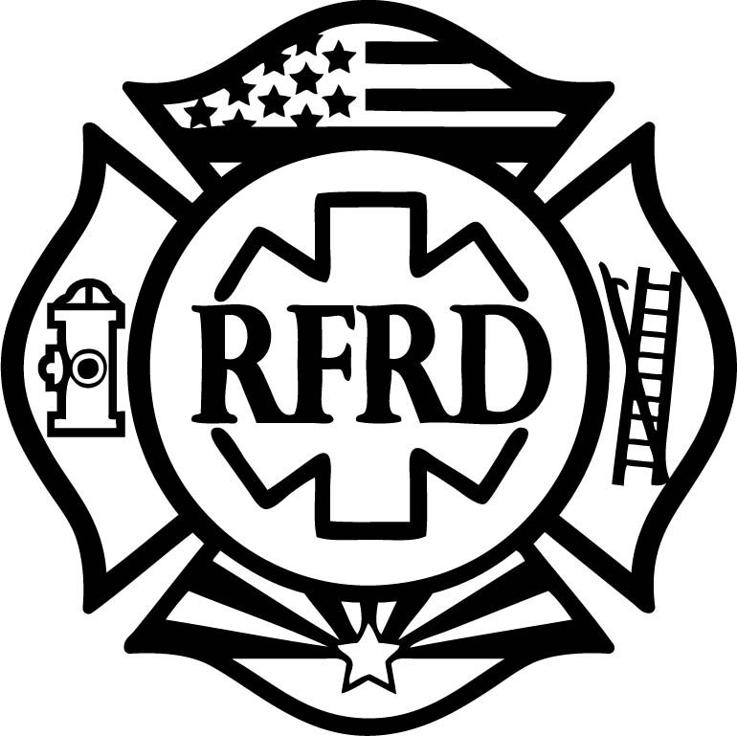
REGIONAL FIRE & RESCUE DEPT.
7951 W. McCartney Road ~ Casa Grande, Arizona 85194-7417
Phone: (520) 723-4680 ~ Fax: (520) 723-4681
www.facebook.com/regionalfire
www.regionalfire.org

FIRE PROTECTION ENROLLMENT FORM
Member(s) Name(s):
Property Street Address:
Number Direction Street Name City State ZIP Code
Mailing Address or POB:
Number Direction Street Name City State ZIP Code
Telephone Nos.: Cell: Work:
E-mail Address:
Emergency Contact: Phone:
Mortgage Company/Address:
Mortgage Phone: Mortgage Fax:
Insurance Policy Number:
Insurance Carrier: Ins. Agent:
Ins. Agent Phone: Ins. Agent Fax:
. . . . . . . . . . . . . . . . . . . . . . . . . For Member Services Representative Use Only . . . . . . . . . . . . . . . . . . . . . . . . . . . . . . . . .
Total (Under-Roof) Square Foot:_________________ Annual Subscription:________________
Date Measured_____________ By: ______________ Admin Fee (one time): $30.00

Total: _______________
Subscriptions begin as low as $154 PER YEAR for a 1400 square foot home, and increases depending on the total under roof square footage of all building(s) on the property. This is an ANNUAL service fee, not monthly. Payment accepted with VISA, Mastercard, or through escrow, send NO MONEY now.
Question: Why Do I have to Pre-pay for Fire Protection?
Fire Protection in the Unincorporated areas of Pinal County are not Automatic, unless you live within the boundaries of an incorporated City (municipal services) or are within the boundaries of an established Fire District. We are not obligated to respond to non-subscribers. Home/Business Owners must establish fire protection through an individual agreement.
Question: I am a Tax-Payer, why won’t Pinal County provide my Fire Protection?
Pinal County Government has no obligation to provide or establish fire protection services. Due to the absence of any specific ordnance, law or mandate, the County will not provide, regulate or issue a contract to a provider for the purpose of providing public service fire protection in Pinal County’s unincorporated areas. As a home or property owner, you must Subscribe for service with a fire protection provider willing to serve your area. Many areas have NO protection at all.
Question: What if I choose not to “subscribe” for Fire Protection from Regional Fire.
We will continue to respond with available Firefighters, EMTs and Paramedics to “All Hazard” incidents and Medical emergencies in your area. We encourage you to become a pre-paid Subscriber under an individual agreement with our agency by first enrolling, and then paying the annual subscription fee. (Avg. Subscription is $250.00 annually). Otherwise, you can continue to be a non-subscriber, in which case the hourly cost is $650.00 per hour, per vehicle, and $45.00 per hour, per Firefighter. Medical responses are $435.00 for Basic Care and $495.00 for Advanced Life Support.

